2KES -

Functionality
If you want to post material stocks, assets, work in process or Additional Balance Sheet Items to Profit Center Accounting by transaction, you need to carry balances forward during the course of year-end closing.
When you carry balances forward, the profit and loss accounts are carried forward to a retained earnings account entered for that income statement account type in Customizing. Postings are divided according to controlling area, profit center, origin object type and transaction. Balance sheet accounts are carried forward under the same account and divided according to controlling area, profit center, partner profit center, partner company, function area, transaction, depreciation area (for assets) and results analysis version (for work in process).
Once you have activated the function for carrying balances forward in Profit Center Accounting, the system performs it automatically in the actual system for all postings which are transferred from Financial Accounting or entered manually in Profit Center Accounting. On the other hand it is recommended to run the Carry forward manually as one of the year-end activities.

Scenario
Carry forward balance of company 5200 of year 2002 to year 2003.

Requirements
None.

Menu Path | Accounting → Controlling → Profit Center Accounting → Actual Postings → Period-End Closing → 2KES - Carrying Forward of Balances
Transaction Code | 2KES

1. Double Click on 2KES - Carrying Forward of Balances.

Profit center: Carry forward actual balance

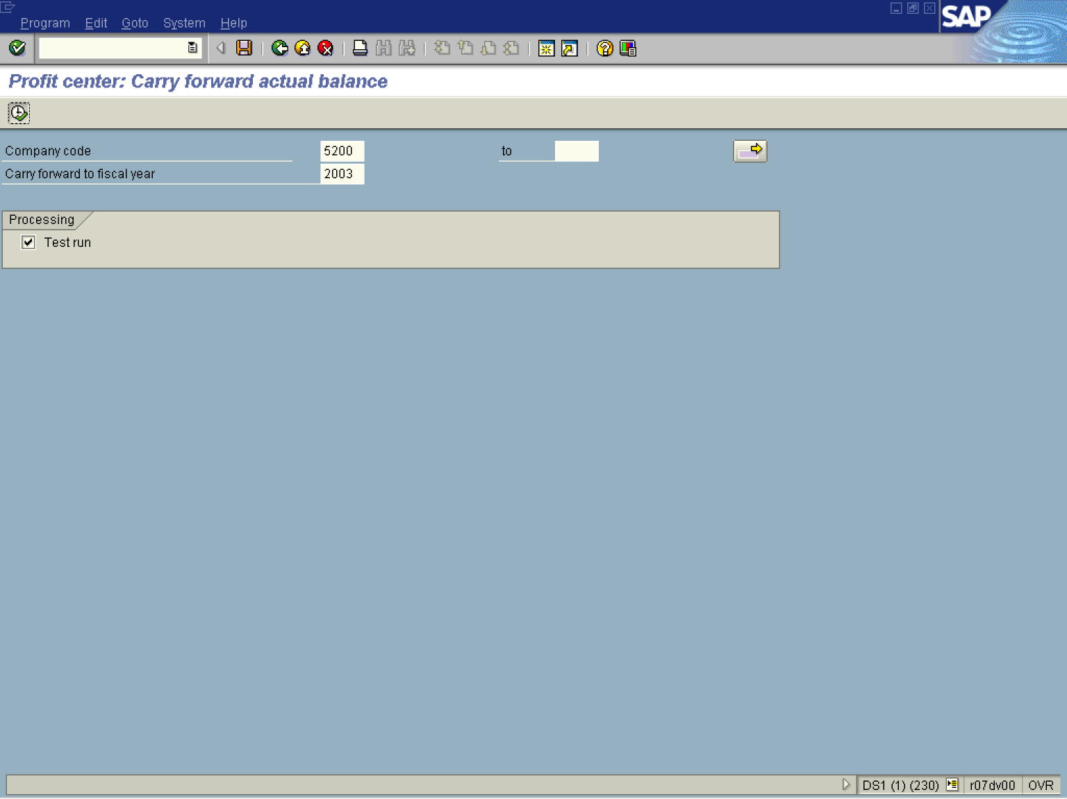
2. Update the following fields:

Field Name | Description | Values
Company Code | Organizational unit within financial accounting. | Example: 5200
Carry forward to fiscal year | Period, 12 months as a rule, for which the company is to create its inventory and balance sheet. | Example: 2003
3. Click Test run .
Note: Processing type for programs, which change data:
When the flag is active: the program is executed normally, all checks in the program are performed, their results are output in various forms (as single message, as a collection of messages, or as a log), but existing data are not changed.
When the flag is inactive: the program is executed normally. All data changes (change, delete, insert new data records) are made in the database (real run).
4. Click Execute Button .
Balance carry forward Ledger 8A for the year 2003 Test run

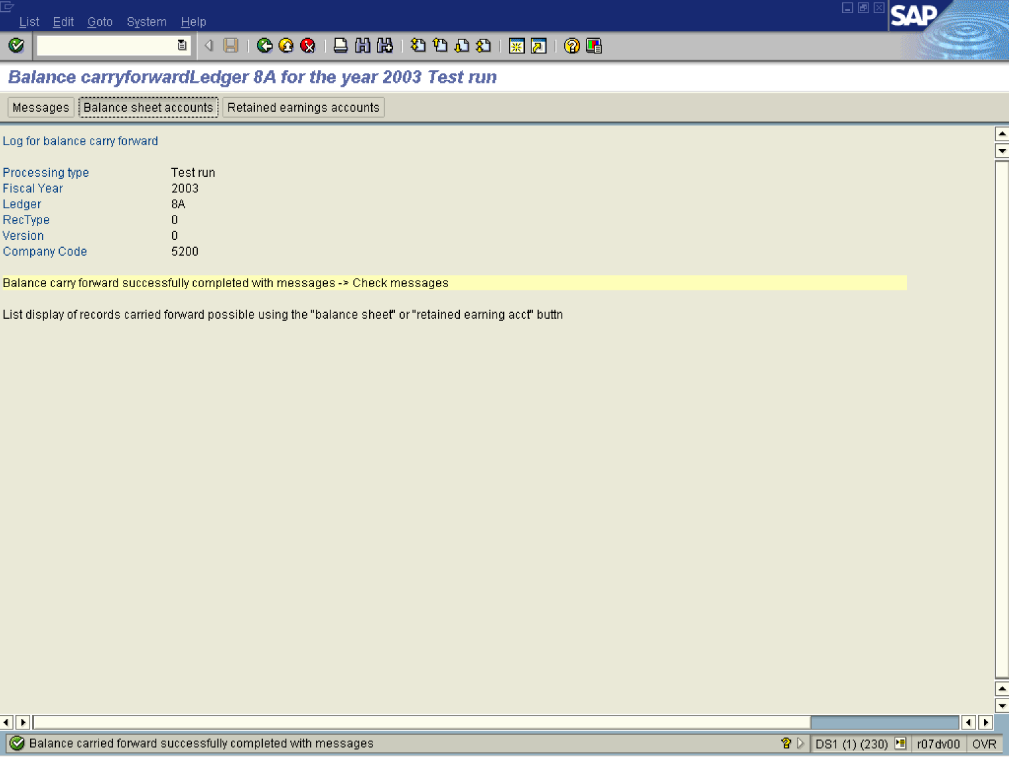

5. Click Balance sheet accounts Button .

Display of balance sheet accounts

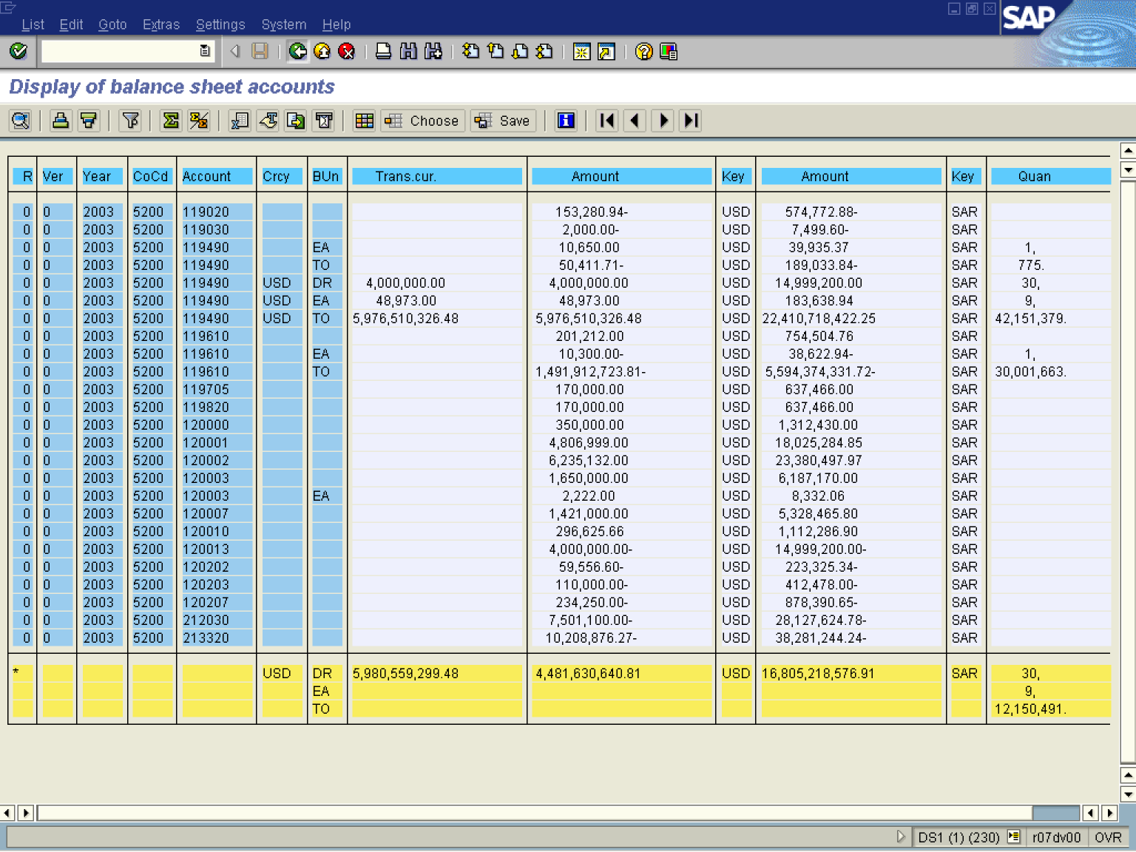

6. Click Back .

Balance Carry forward for the year 2003 Test run

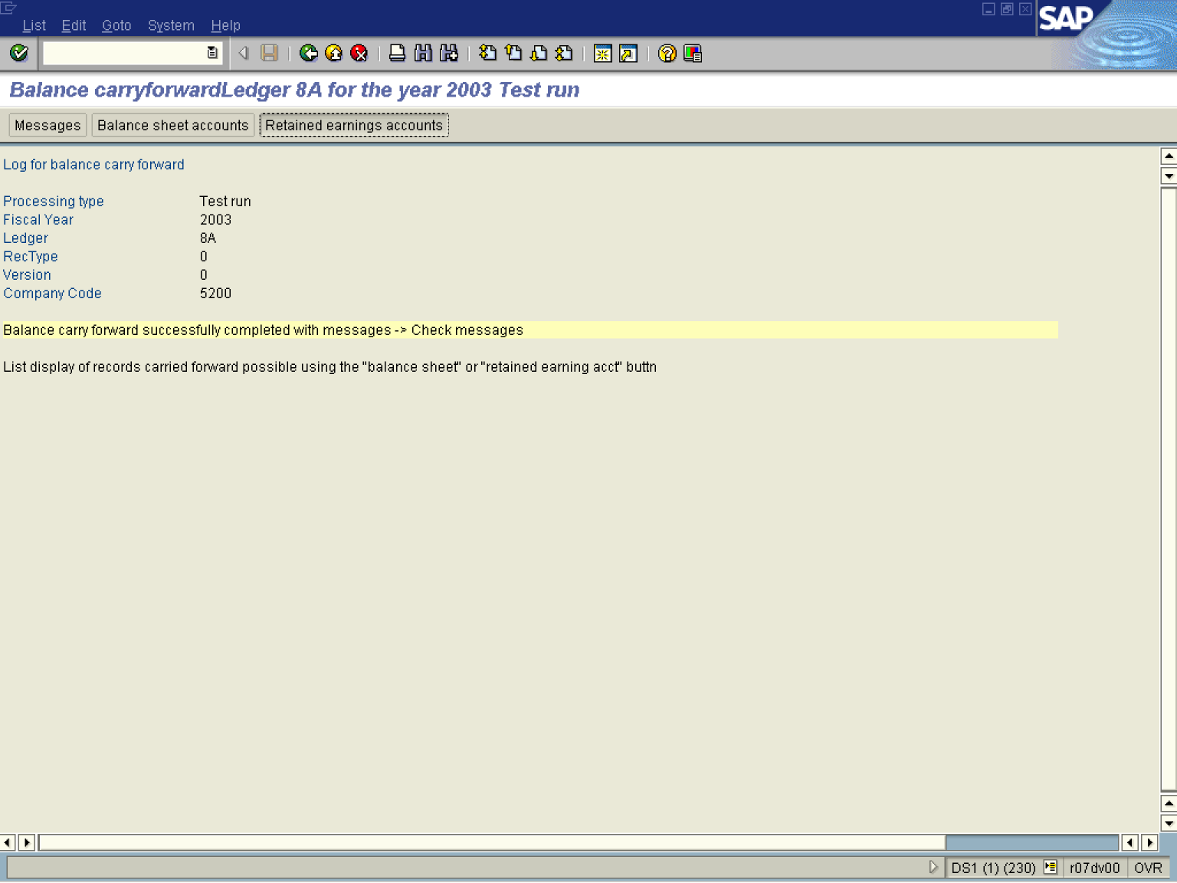

7. Click Retained earnings accounts Button .

Display of retained earnings accounts

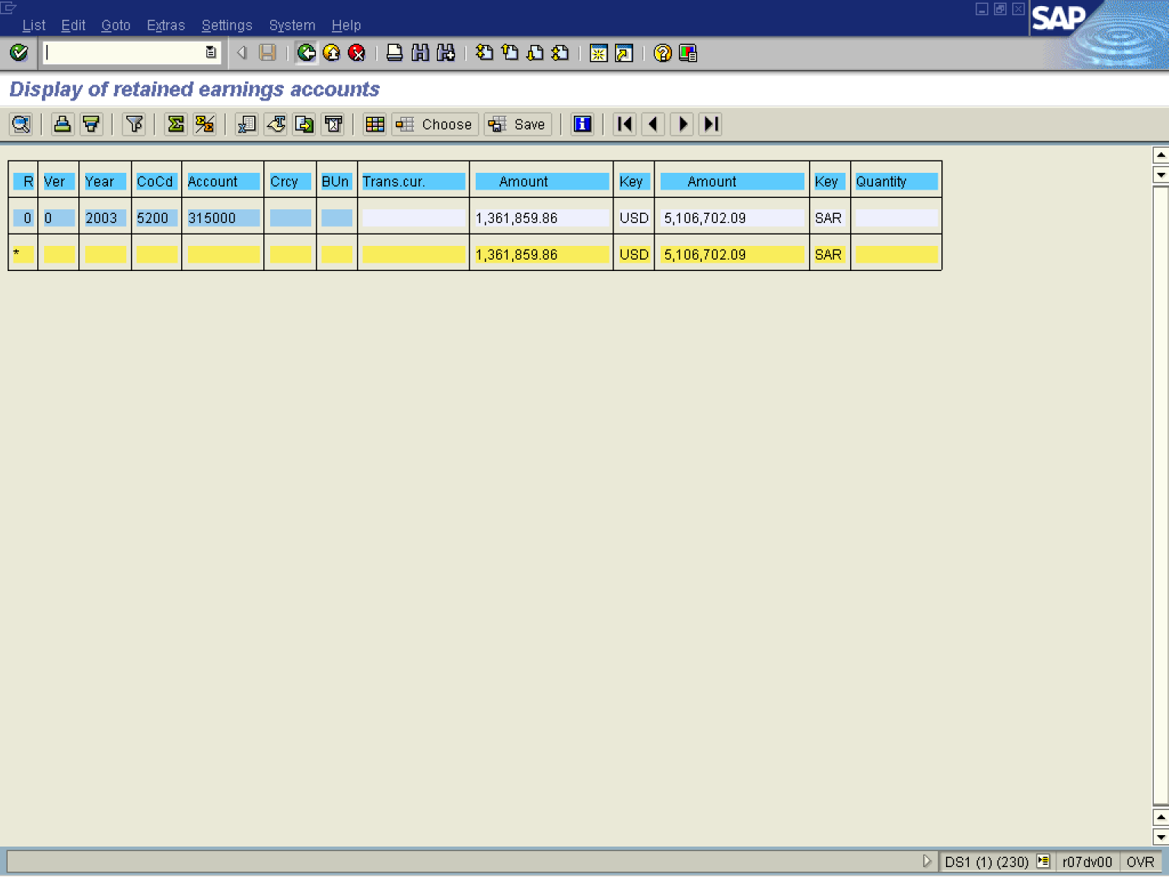

8. Click Back .

Balance carry forward for the year 2003 Test run

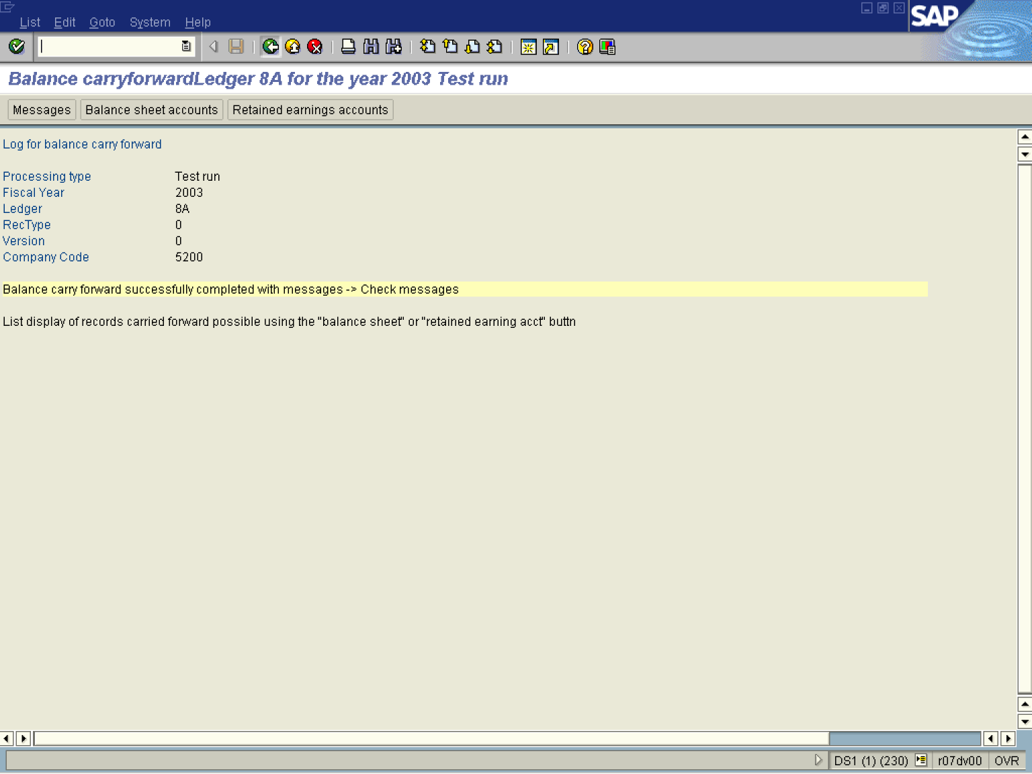

9. Click Back .

Profit center: Carry forward actual balance

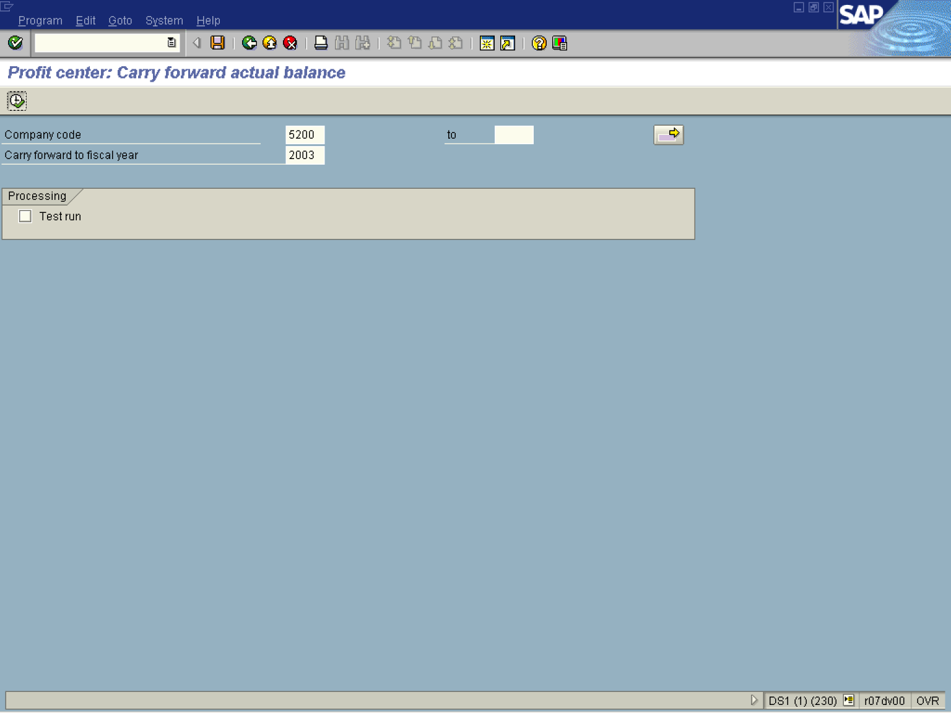

10. If satisfied by the results uncheck the <checkbox> Test run .

11. Click Execute Button .

Balance carry forward for the year 2003 Update run

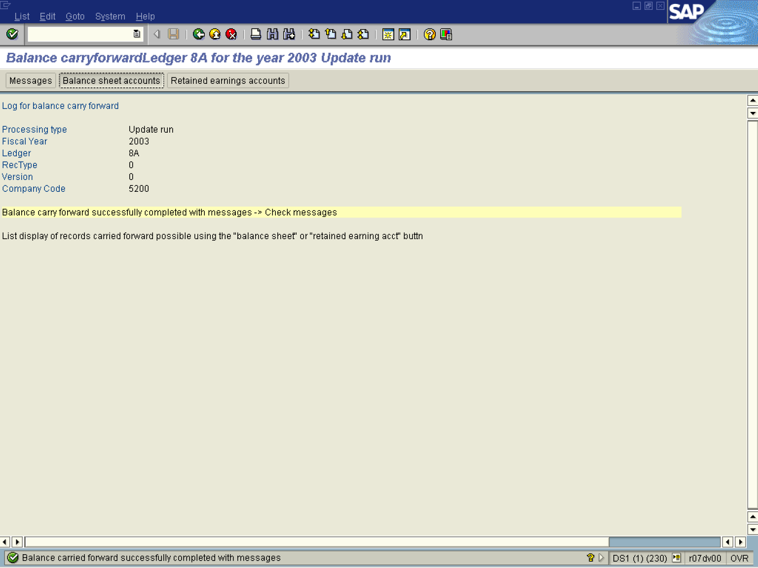

12. Click Balance sheet accounts Button .

Display of balance sheet accounts

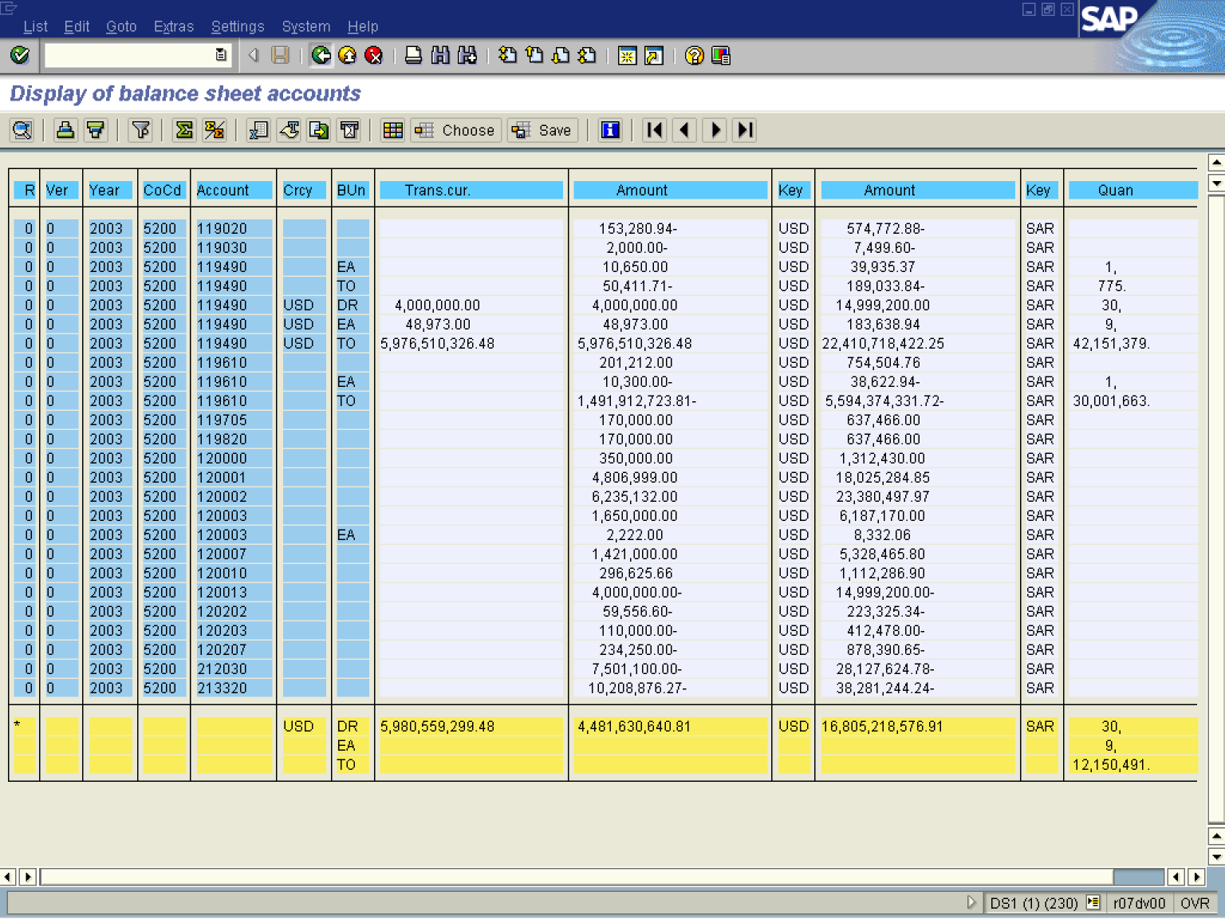

13. Click Back .

Balance carry forward Ledger 8A for the year 2003 Update run

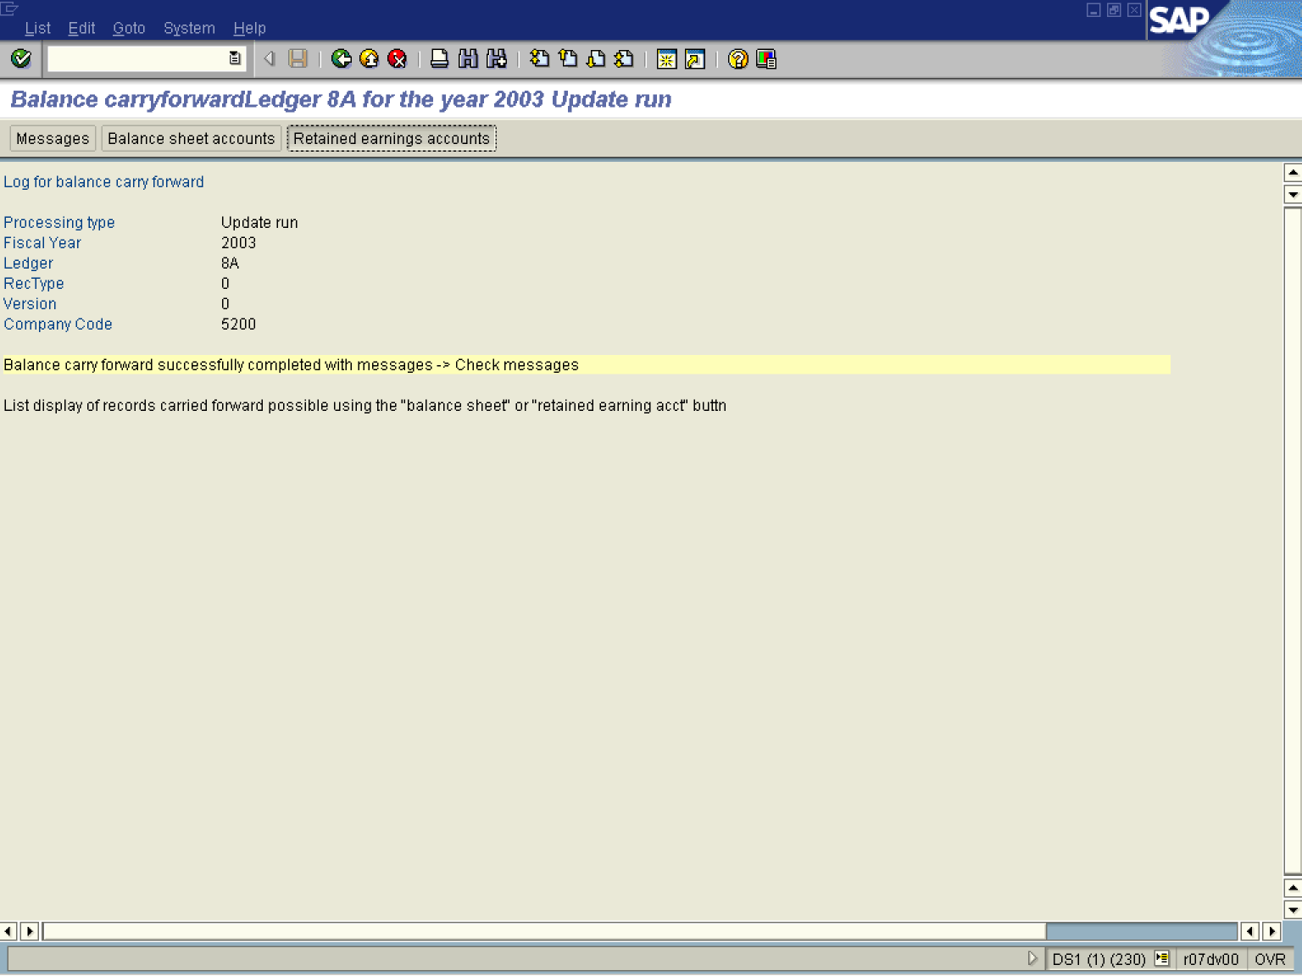

14. Click Retained earnings accounts Button .

Display of retained earnings accounts

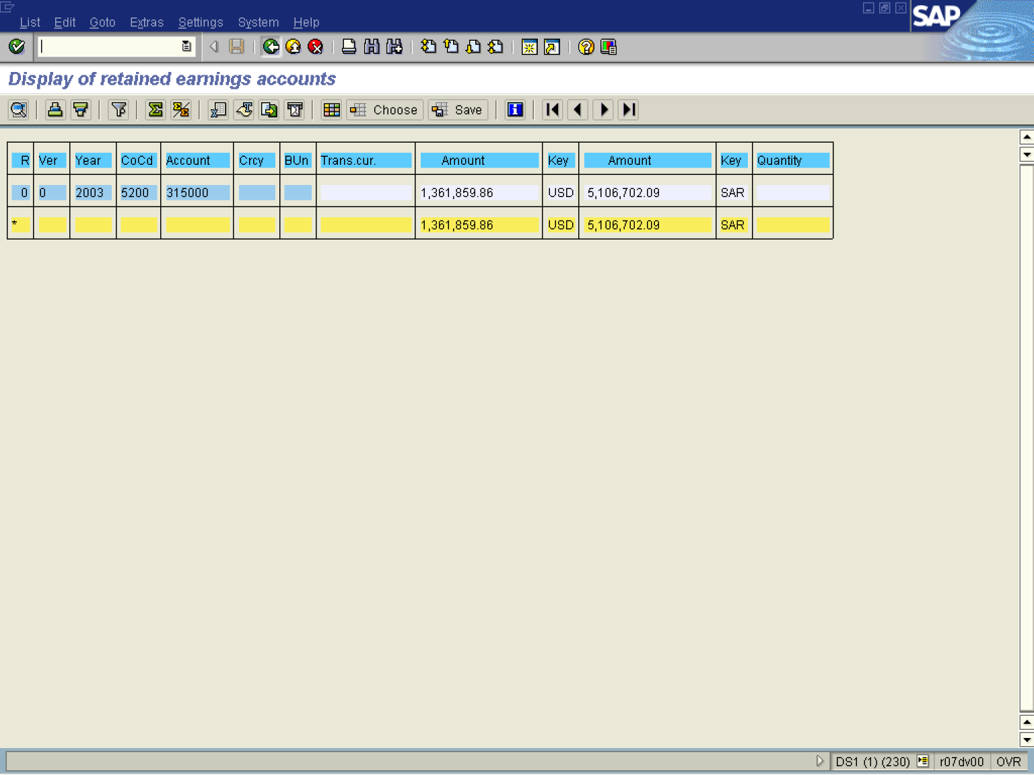

15. The system displays a list of retained earning account balances.

